REPORT FOR TASK 7, VARIANT 8

1. First subtask:

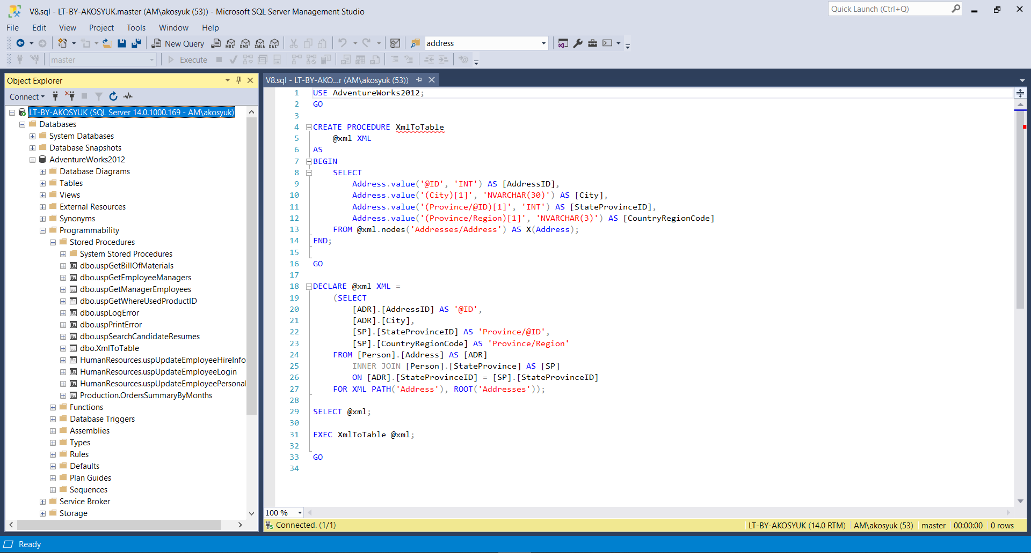

2. XML:

<Addresses>

<Address ID="532">

<City>Ottawa</City>

<Province ID="57">

<Region>CA</Region>

</Province>

</Address>

<Address ID="497">

<City>Burnaby</City>

<Province ID="7">

<Region>CA</Region>

</Province>

</Address>

...

</Addresses>